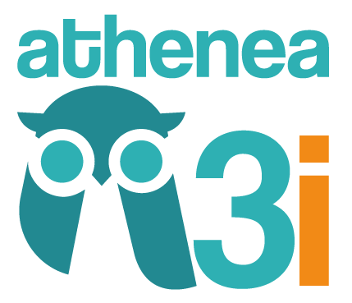

ATHENEA3i FELLOWSHIP PROGRAMME

SECOND CALL FOR APPLICATIONS - 2018

APPEAL APPLICATION FORM

FOR REMOTE ASSESSMENT



ATHENEA3i

Attracting and Encouraging Triple 'I' Talent Mobility

Marie Skłodowska-Curie COFUND Actions

ATHENEA3i FELLOWSHIP PROGRAMME - SECOND CALL 2018 APPEAL APPLICATION FORM FOR REMOTE ASSESSMENT

It is mandatory to complete and submit the Appeal Application Form[1] in order for the appeal to be considered. Once the Appeal Application Form has been properly completed, it must be printed and signed by the applicant. This Form must be submitted as a single PDF file via this link: <http://investigacion.ugr.es/pages/planpropio/p21athenea>. In order to submit it, you need to enter in your account using the user and password provided you during the application process.

Please introduce your comments regarding the cause/s of appealing:

Comment section

4000 characters maximum with spaces

Proposal number*:

Name*:

Last name*:

Signature*:

**Appeal Application Period**: From **21 February 2019 to 1 March 2019 at 13:00** (Spanish time/**CET**). Any appeal received after the deadline will not be accepted.

1. Applicants are responsible for ensuring that the file is uploaded correctly and that the contents are legible. In the event that the documents cannot be read properly, applicants will be unable to submit any further appeals.